# Lab: Selecting Data from a Database

Note

All labs rely on information from the current and previous lessons, activities and labs.

Helpful Hints

If you need more space to work in the MySQL Workbench, there are a few options:

1. You may toggle the instructions with the - in the upper-right corner.
2. Toggle Fullscreen view with the X icon in the upper-right corner.
3. Use your browser's zoom-out feature. Zoom out: [CTRL-minus] or [CMD-minus]; Zoom-in: [CTRL-plus] or [CMD-plus].

If you need to reset your database and/or discard your changes, click the mysql button above, then Reset DB.

## Lab Overview

### Scenario

Inventory management is one of the tasks that you have been asked to support with your database from your client, the Canal House Books store. You have been provided an inventory report that can be added to the SQL database. Using this report, identify items that need to be ordered or removed from stock.

### Objectives

In this lab, you will:

* Import the inventory report table
* Find items that are out of stock to reorder them from the inventory table
* Locate items that are not selling to remove them from the inventory table

## Estimated Completion Time

10–20 minutes

## Exercise 1: Import Inventory CSV

The store has kept track of books sold over the past few years and wants to use this to inform inventory business decisions quickly. Import the csv file into a new table in your database, pub1.

### TODO

Insert the inventory report from work/InventoryReport.csv into the database using the table name inventory.

### Steps

1. Ensure that you are logged into the workspace and have MySQL Workbench open and are connected to the pub1 database.
2. Right click the Tables tab in pub1 and select Table Data Import Wizard.
3. Click Browse and browse to the path to select your work/InventoryReport.csv file to import. Click Open; then click Next.
4. Next to Create new table, ensure pub1 is selected. Type inventory into the name field and click Next.
5. In the Configure Import Settings portion of the import wizard, verify that the source columns match up to the appropriate destination columns and click Next.
6. Click Next to execute the import of the csv file. Click Next and Finish.
7. In the Schemas pane, right-click and select Refresh All to populate the inventory table.

## Exercise 2: Select Books for Reordering

The manager of the store has asked that you create a query that will be able to identify which books have a low quantity. Any book that has less than 5 copies remaining is in need of ordering. Create a query the manager can use to quickly identify all books that need to be ordered based on these criteria. Sort the results by the most sold product being at the top.

### TODO

Using the inventory table, create a SELECT query to identify all books that have fewer than five items remaining in the inventory sorted by amount sold in descending order.

### Steps

1. In Workbench, click the Query tab in the main view.
2. Enter the following query to look for all books that have a quantity fewer than 5

SELECT * FROM pub1.inventory WHERE qty < 5

1. Click the execute lightning bolt to execute the query.

### Example View

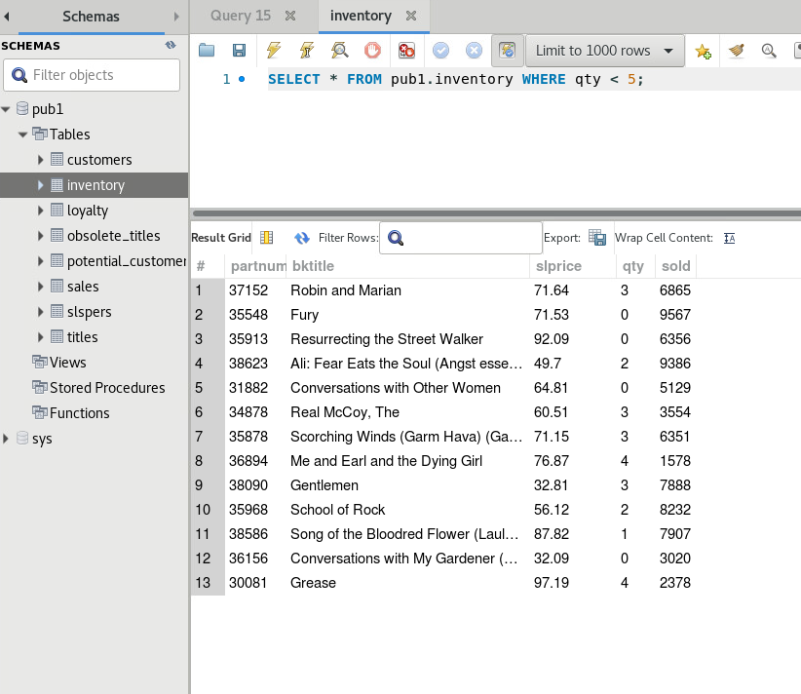

## Exercise 3: Select Low-Selling Books

Anticipating additional requirements from the customer can sometimes be a good thing and save you some work later on down the line. In this case, you have anticipated that the manager will probably want to know what items have sold the least. Use 100, 200, and 500 thresholds to create a set of queries to inform the manager.

### TODO

Create three different SELECT queries to identify books that have sold less than 100, 200, and 500.

### Steps

1. From the pub1 database, select the inventory table.
2. Right click on the inventory table and select the Select rows – Limit 1000 option.
3. Delete the previous query and type the following line to only include books that have sold fewer than 100 copies.

SELECT * from pub1.inventory WHERE sold < 100;

1. Click the lightning bolt to execute the query.  
   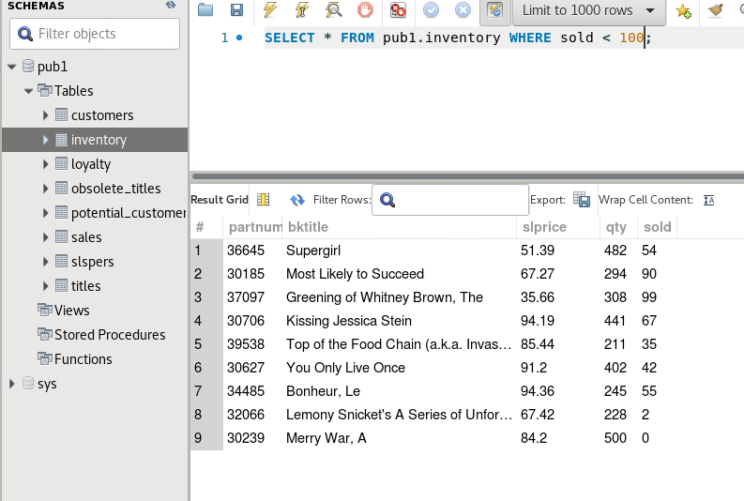
2. Create two additional queries for 200 and 500 copies below your first query.

Click the lightning bolt with the cursor, the one in the center, to execute the queries individually based on your cursor location.

### Example View

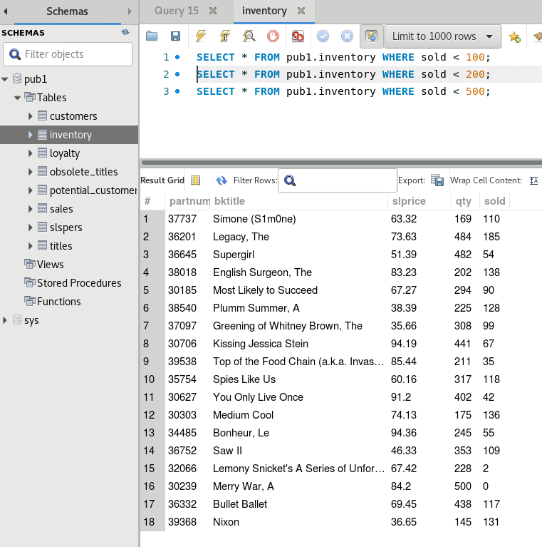

## STOP

You have successfully completed this lab.